**Installation and Maintenance Instructions**

# **For Two Leg V & Two Leg U Style Loops**

# **Installation**

1. Be sure all pipelines are supported so the two-leg flexible loop does not carry the pipe load.
2. Initial pipe misalignment must not exceed 1/8” in any direction.
3. Install the two-leg flexible loop with the neutral face-to-face dimension as shown on the submittal drawing. If anchors are designed into the piping system, they need only be sized to accommodate the forces of the piping system, since the two-leg flexible loop imposes no additional thrust forces.
4. If the two-leg flexible pipe loop must be installed with an initial misalignment, compression, or extension, then the maximum allowable movements are reduced by the amount of the initial deflection.
5. Verify that the movements of the system are within the design parameters of the two-leg flexible loop being installed.
6. Check system pressure and temperature and do not exceed recommended performance limits. Operation beyond design limits will result in premature failure.
7. The two-leg flexible loop alloy must be chemically compatible with the media in the piping system. If in doubt as to suitability, refer to a Chemical Resistance Data table or contact Flex-Hose Co. for guidance.
8. The flanges on a flanged two-leg flexible loop have the bolt holes straddling the hose centerline. The mating flanges should also straddle the centerline to avoid torque on the two-leg flexible pipe loop.
9. When installing weld end two-leg flexible loops, or when welding in the area of a two-leg flexible loop, extreme care is necessary to ensure no weld spatter comes in contact with the braided hose sections.
10. Press fit fittings require the tube to be square and burr free. Do not use oils or lubricants and only use the manufacturers pre-lubricated sealing elements. Do not mix press fit fittings from different manufacturers. Always use the fitting manufacturer’s instructions for proper pressing and test.
11. In “nested” two-leg flexible loop applications there will be individual tags on each flexible loop to designate its location. This should be compared against the submittal drawing to ensure each loop is properly placed. To install a thread end two-leg flexible loop unions must be used. Do not place wrenches on the braided portion or the collar of the flexible pipe loop. Use care not to torque the two-leg flexible loop while tightening the union.
12. Use care when handling the two-leg flexible loop during transportation, storage, and installation. The braided hose sections must not be allowed to bend, deflect, sag, or otherwise extend beyond their rated capabilities.
13. The shipping bar is to keep the two-leg flexible loop in its neutral end-to-end dimension during shipping and installation. After installation, the shipping bar should be removed.
14. Because the two-leg flexible loop is rated for motion either side of its neutral face-to-face, the capability can be doubled by pre-compressing or pre-extending based on the requirement.
15. A pipe guide is required on two-leg flexible loops, one on either side of the flexible loop, within 4 times the pipe diameter, when used in thermal applications.
16. **SPECIAL NOTE:** When installed in any configuration other than with two-leg flexible loop hanging down (pipe horizontal), the weight of the two-leg flexible loop must be supported utilizing the support lug provided at bottom of the 90° elbows. A chain, cable, or other suitable means of support must be used to support the weight of the two-leg flexible loop and the media being conveyed. **Flex-Hose Flexible Loop cable kits with break strength certified cable and UL approved components is the perfect choice.** Care should be used not to allow the chain, cable, or other support to come in contact with the braided hose sections of the two-leg flexible loop. Any repeated contact with the braided hose section will cause exterior abrasion and thus pre-mature failure. [See reverse for application support suggestions.]
17. Large flexible loops may require support of the braided hose section due to the weight of the loop, the media being conveyed and or the length of the braided section. A hose bun or similar device can be used, that will not cause abrasion to the braided hose section, to maintain the leg(s) in a straight fashion.
18. **SPECIAL NOTE:** In accordance with specified installation/application requirements the elbow port is positioned to allow continual removal of condensate or gases. Proper fluid draining or gas purging techniques/practices must be followed to avoid safety issues/concerns.

### **Maintenance**

1. In the event of seismic activity, the two-leg flexible loops should be inspected to ensure it has not suffered damage from movement greater than its designed capability. If there is any question as to whether or not excessive motion has occurred, the two-leg flexible loop should be re-tested. If determined that excessive movement beyond design capability has occurred, the two-leg flexible loop should be replaced.
2. The two-leg flexible loop should be inspected during routine maintenance to ensure there are no signs of external damage. Inspect for frayed or broken braid wires. Also inspect to ensure there is no damage to the hose. If such damage is found, the flexible pipe loop should be replaced.

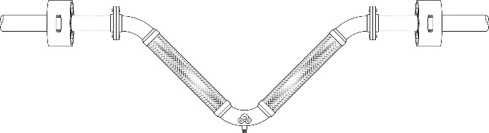

# **Horizontal Pipe Run with Vertical Two-leg Flexible Loop**

Typical installation requires no further support of the two-leg flexible loop

# **Horizontal Pipe Run and Two-leg Flexible Loop**

The two -leg flexible loop requires support at the bottom elbow lug with cable or other such device to carry the weight of the two-leg flexible loop and the media conveyed.





# **Vertical Pipe Run with Vertical Two-leg Flexible Loop**

The two-leg flexible loop requires support at the elbow lug with cable or other such device to carry the weight of the two-leg flexible loop and the media conveyed.

# **Horizontal Pipe Run with Vertical Two-leg Flexible Loop**

The two-leg flexible loop requires support at the elbow lug with cable or other such device to carry the weight of the two-leg flexible loop and the media conveyed.

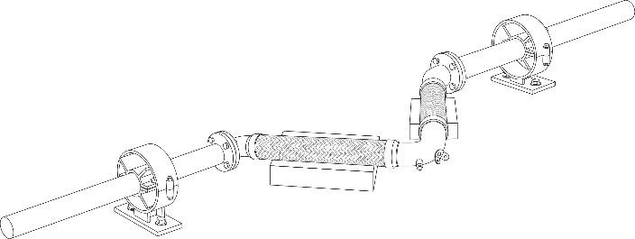

**Horizontal Pipe Run and Two-leg Flexible Loop On Floor**

The two-leg flexible loop requires elevated support to allow free movement from the floor. SPECIAL NOTE: The support under the non-parallel leg must be of a non-abrasive material to prevent damage to the braided hose of the two-leg flexible loop.

**SPECIAL NOTE: Illustrations may show a two-leg U style or a two-leg V style. Supporting requirements are the same for either style.**