Installation and Maintenance Instructions

for Tri-Loop® Flexible Pipe Loop

Installation

- Be sure all pipelines are supported so the Tri-Loop does not carry the pipe load.
- Initial pipe misalignment must not exceed 1/8” in any direction.
- Install the Tri-Loop with neutral face-to-face dimension as shown on the submittal drawing. If anchors are designed into the piping system they need only be sized to accommodate the forces of the piping system, since the Tri-Loop imposes no additional thrust forces.
- If the Tri-Loop must be installed with an initial misalignment, compression, or extension, then the maximum allowable movements are reduced by the amount of the initial deflection.
- Verify that the movements of the system are within the design parameters of the Tri-Loop being installed.
- Check system pressure and temperature and do not exceed recommended performance limits. Operation beyond design limits will result in premature failure.
- The Tri-Loop alloy must be chemically compatible with the media in the piping system. If in doubt as to suitability, refer to a Chemical Resistance Data table or contact Flex-Hose Co. for guidance.
- The flanges on a flanged Tri-Loop have the bolt holes straddling the hose centerline. The mating flanges should also straddle the centerline to avoid torque on the Tri-Loop.
- When installing weld end Tri-Loops, or when welding in the area of a Tri-Loop, extreme care is necessary to ensure no weld spatter comes in contact with the braided hose sections.
- Press fit fittings require the tube to be square and burr free. Do not use oils or lubricants and only use the manufacturers pre-lubricated sealing elements. Do not mix press fit fittings from different manufacturers. Always use the fitting manufacturer’s instructions for proper pressing and test.
- Large flexible loops may require support of the braided hose section due to the weight of the loop, the
weight of the material being conveyed and or the length of braided section. A hose bun or similar device can be used, that will not cause abrasion to the braided hose section, to maintain the legs(s) in a straight fashion.
- In “nested” Tri-Loop applications there will be individual tags on each Tri-Loop to designate its location. This should be compared against the submittal drawing to ensure each loop is properly placed.
- To install a thread end Tri-Loop unions must be used. Do not place wrenches on the braided portion or the collar of the Tri-Loop. Use care not to torque the Tri-Flex-Loop while tightening the union.
- Use care when handling the Tri-Loop during transportation, storage, and installation. The braided hose sections must not be allowed to bend, deflect, sag, or otherwise extend beyond their rated capabilities.
- The shipping bar is to keep the Tri-Loop in its neutral end-to-end dimension during shipping and installation. After installation, the shipping bar should be removed.
- Because the Tri-Loop is rated for motion either side of its neutral face-to-face, the capability can be doubled by pre-compressing or pre-extending based on the requirement. With the extreme flexibility of the Tri-Loop this can easily be done in the field.
- SPECIAL NOTE: When installed in any configuration other than with the Tri-Loop™ hanging down (vertical), the weight of the Tri-Loop™ must be supported utilizing the support lug provided at two of the 90° elbows. A chain, cable, or other suitable means of support must be used to support the weight of the Tri-Loop™ and the media being conveyed. Care should be used not to allow the chain, cable, or other support to come in contact with the braided hose sections of the Tri-Loop. Any repeated contact with the braided hose section will cause exterior abrasion and thus pre-mature failure. [See reverse for application support suggestions.]
- SPECIAL NOTE: In accordance with specified installation/application requirements the elbow port is positioned to allow continual removal of condensate or gases. Proper fluid draining or gas purging techniques/practices must be followed to avoid safety issues/concerns.

Maintenance
* U.S. Patent No. 10,458,575 B2
CAN Patent No. 2,970,107

- In the event of seismic activity, the Tri-Loop should be inspected to ensure it has not suffered damage from movement greater than its designed capability. If there is any question as to whether or not excessive motion has occurred, the Tri-Loop should be re-tested. If determined that excessive movement beyond design capability has occurred , the Tri-Loop should be replaced.

- The Tri-Loop should be inspected during routine maintenance to ensure there are no signs of external damage. Inspect for frayed or broken braid wires. Also inspect to ensure there is no damage to the hose. In the event that such damage is found, the Tri-Loop should be replaced.

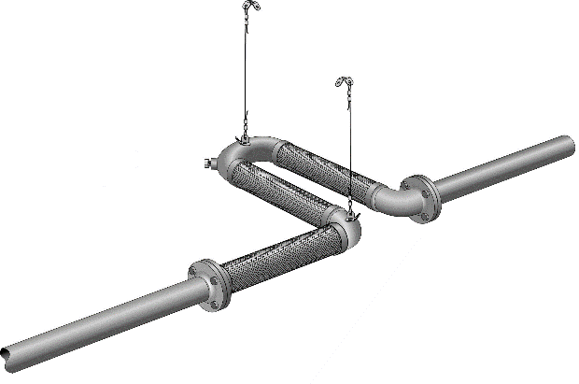
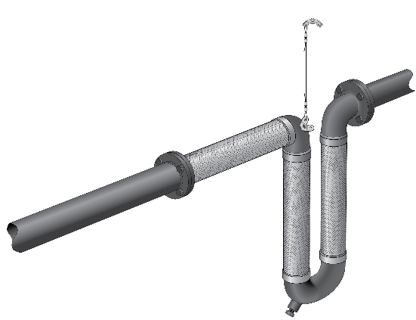

Horizontal Pipe Run with Vertical *Tri-Loop®
Typical installation requires support at the 90 degree elbow that joins two of the flexible sections.

Horizontal Pipe Run and *Tri-Loop®
The Tri-Loop requires support at the 180 degree return lug and at the 90 degree elbow that joins two flex with cable or other such device to carry the weight of the Tri-Loop and the media conveyed.

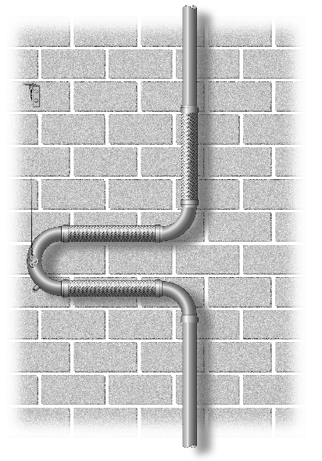

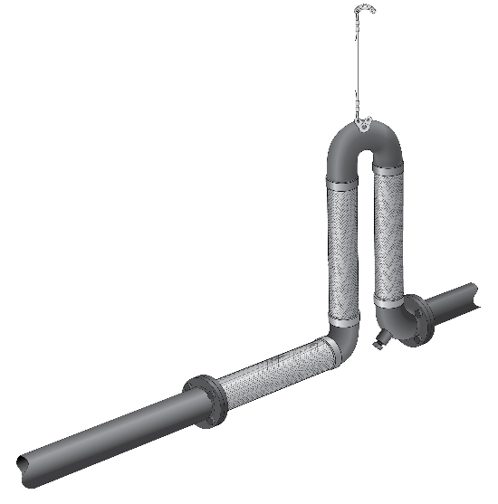

Vertical Pipe Run with Vertical *Tri-Loop®
The Tri-Loop requires support at the return elbow lug with cable or other such device to carry the weight of the Tri-Loop and the media conveyed. The non-parallel leg should be lower than the two parallel legs. Piping below the Tri-Loop should be supported so the weight of the piping below the loop is not carried by the Tri-Loop.

Horizontal Pipe Run with Vertical *Tri-Loop®
The Tri-Loop requires support at the return elbow lug with cable or other such device to carry the weight of the Tri-Loop and the media conveyed.

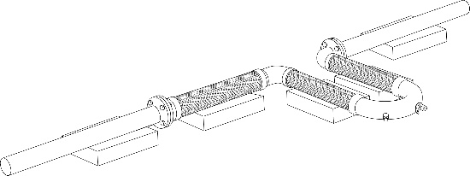

Horizontal Pipe Run and *Tri-Loop® on Floor/ Roof
The Tri-Loop requires elevated support to allow free movement from the floor. SPECIAL NOTE: The support under the non-parallel leg must be of a non-abrasive material to prevent damage to the braided hose of the Tri-Loop

* U.S. Patent No. 10,458,575 B2
CAN Patent No. 2,970,107

